What is this simple machine?

What is this simple machine?

What is this simple machine?

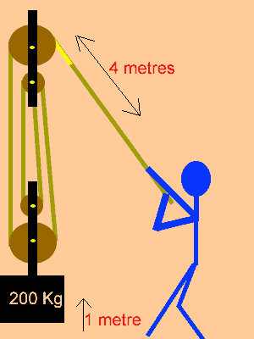

What is this simple machine?

What is this simple machine?

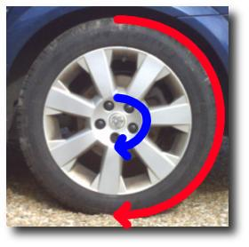

Name the 6 simple machines

What is this simple machine?

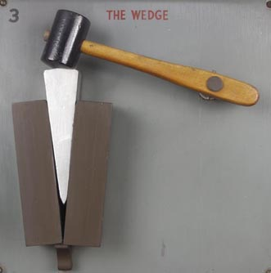
What is this simple machine?
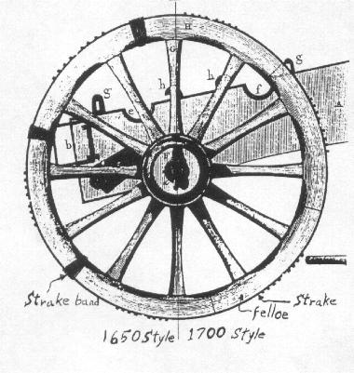

In physics, a wedge is defined as?

In physics, a Pulley is defined as?

Pulley

Wedge

Pulley

Pulley

Inclined plane
Screw
Pulley
Lever
Wedge
Wheel and Axle

Wheel and Axle

Wheel and Axle

Wedge

A simple machine consisting essentially of a wheel with a grooved rim in which a line can run to change the direction of the pull and thereby lift a load

A pair of inclined planes set back-to-back.

